Lab Practical #03:
Study of different types of network cables & connectors and crimping a LAN.
Practical Assignment #03:
- List various networks cable. Also, write short description.
- Difference between guided and unguided media.
- Give cross-wired cable and straight through cable diagram (Color Code wise).

List various networks cable and connectors. Also, write short description.
- Network Cable Name: Twisted Pair Cable (UTP/STP)
  - Description:
• Most commonly used cable in LAN.
• Wires are twisted in pairs to reduce electromagnetic interference.
• UTP (Unshielded Twisted Pair) – No extra shielding, cheaper.
• STP (Shielded Twisted Pair) – Extra shielding for better noise resistance.
• Used with RJ45 connectors.
  - Diagram:
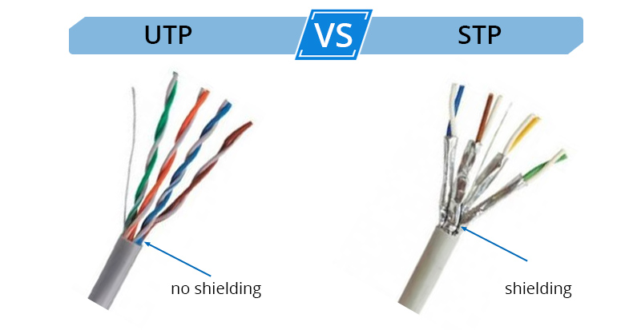

- Network Cable Name: Coaxial Cable
  - Description:
• Used in older LANs, cable TV, and broadband.
• Has a central copper core, insulating layer, braided shield, and outer cover.
• Good resistance to signal interference.
  - Diagram:
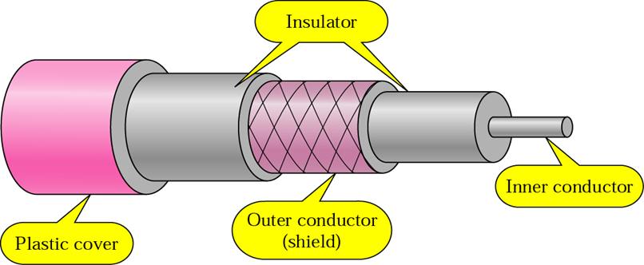

- Network Cable Name: Fiber Optic Cable
- Description:
- Transmits data as light signals (not electrical).
- Extremely high speed and long-distance transmission.
- Immune to electromagnetic interference.
- Two types: Single Mode (long distance), Multi Mode (shorter, cheaper).
- Diagram:
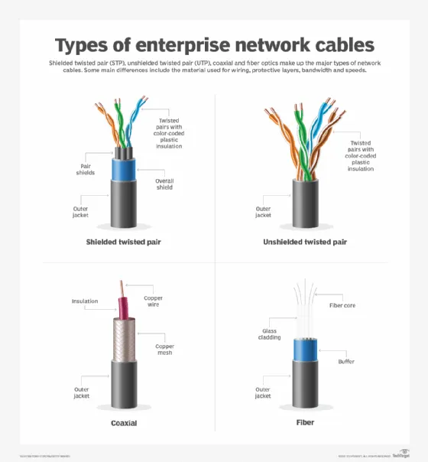

- Difference between guided and unguided media.
Guided Media (Wired)
  Unguided Media (Wireless)
Data signals travel through a physical medium
  Data signals travel through air or vacuum
Uses cables like Twisted Pair, Coaxial, Fiber Optic
  Uses Radio waves, Microwaves, Infrared
  Signals follow a specific path
  Signals spread in all directions
  More complex and costly to install
  Easier and cheaper to set up
Example: | Example:  Wi-Fi, Bluetooth, Satellite, Mobile networks
  Ethernet cables (Cat5, Cat6), Fiber optics

Give cross-wired cable and straight through cable diagram (Color Code wise).
- Cross-wired Cable Diagram (Color Code)
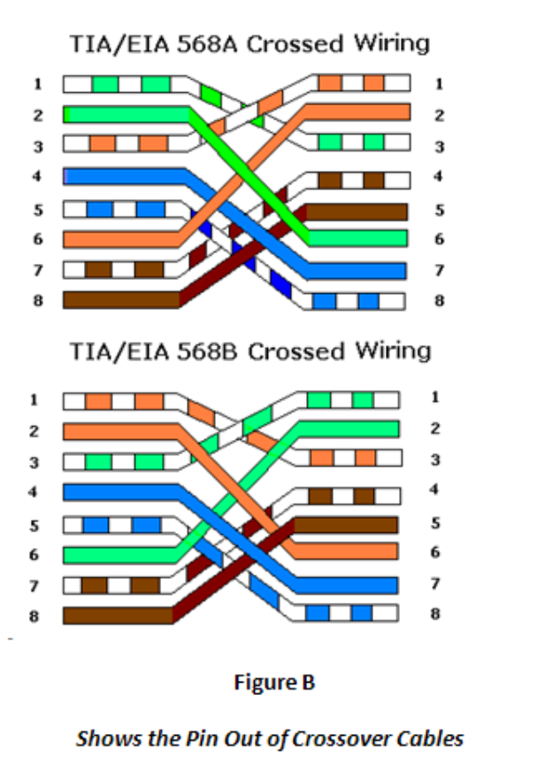

- Straight Through Cable Diagram (Color Code)
